**NAME : SAYAM MANOJ THOLE**

**DIV : 2**

**MIS NO : 111903093**

**-----------------------------------------------------**

**A-1)**

**int** Z;

**void** **main**()

{

**int** a, b, c;

**int** p = 6;

**int** q;

// double r;

a = 10;

b = 20;

c = a * b + 25;

p = 6;

q = Z;

/* r = 34.5;

Z = r;

Z = Z + 1;

*/

}

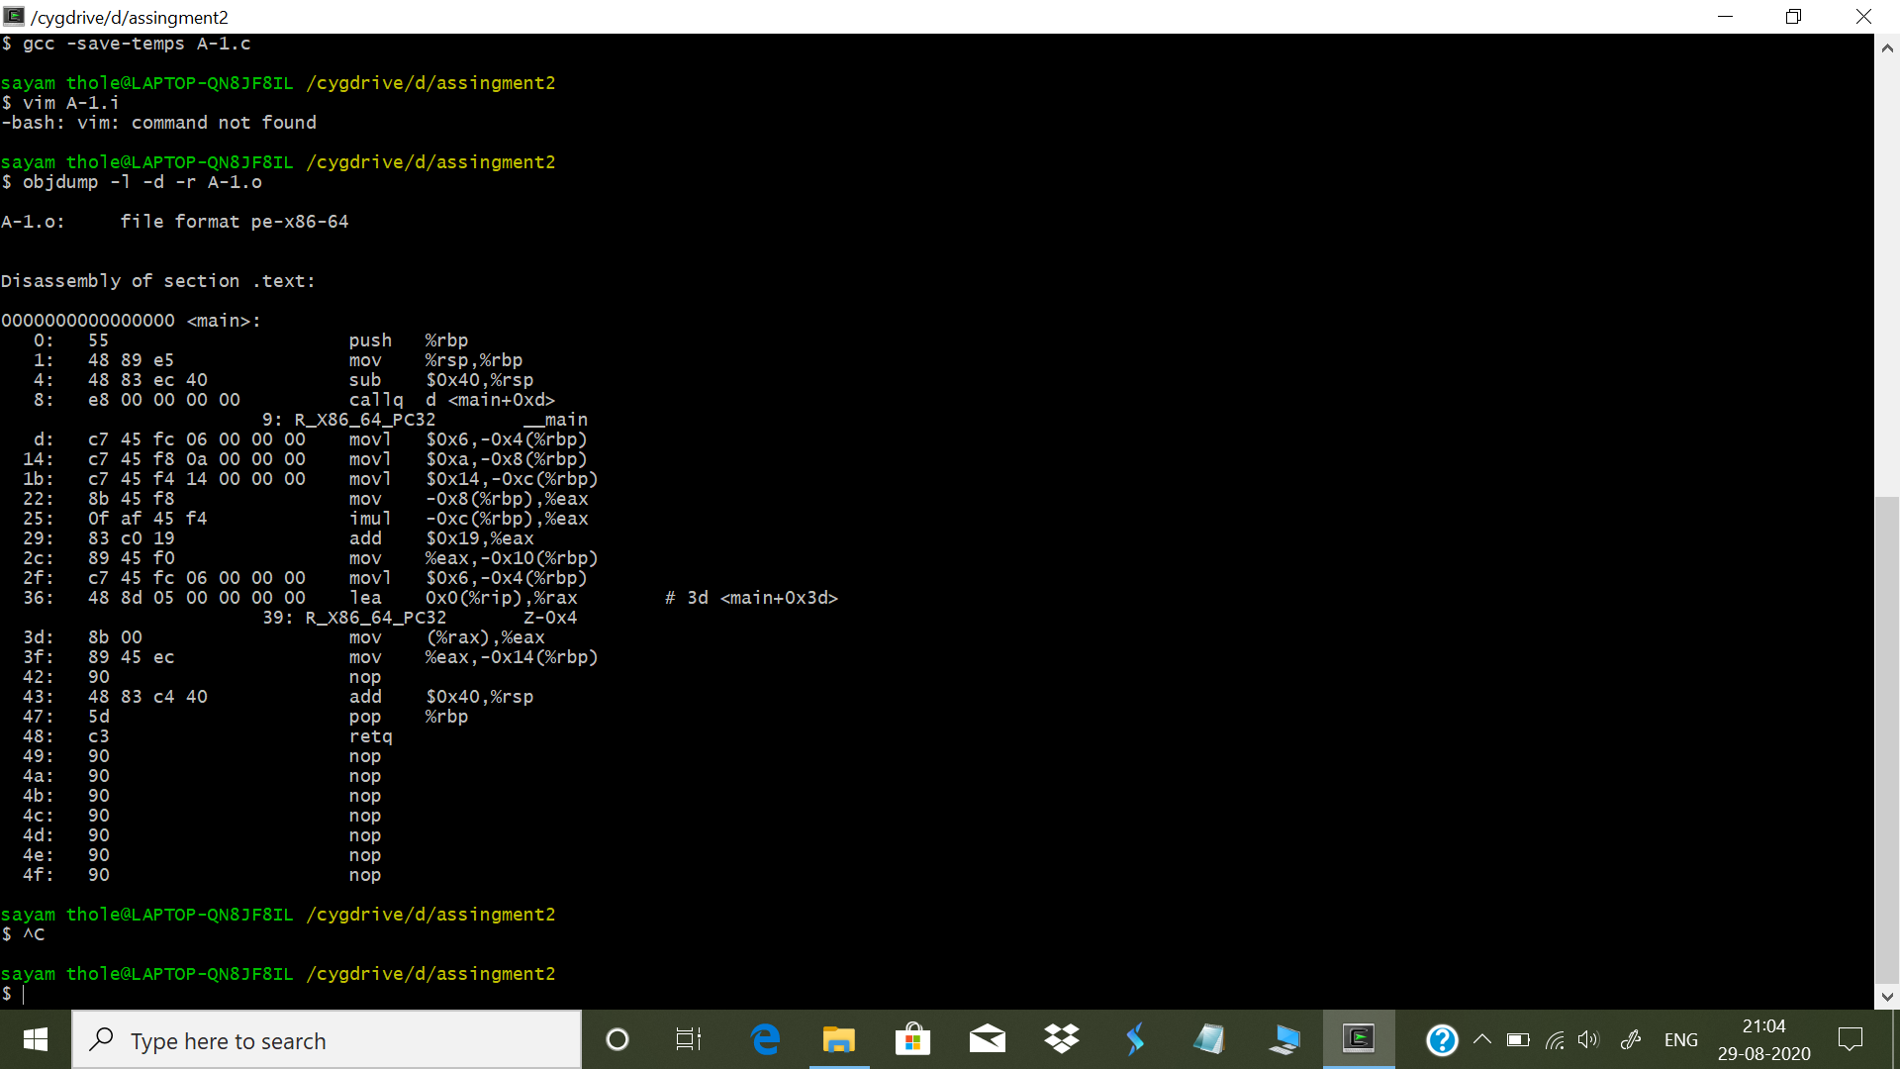

**A-2)**

int Z;

void f()

{

int a, b, c;

a = Z;

if (a < 10) {

b = 5;

c = 17;

} else {

b = 6;

c = 20;

if (a == 0) {

c = 0;

}

}

Z = b * 10 + c;

}

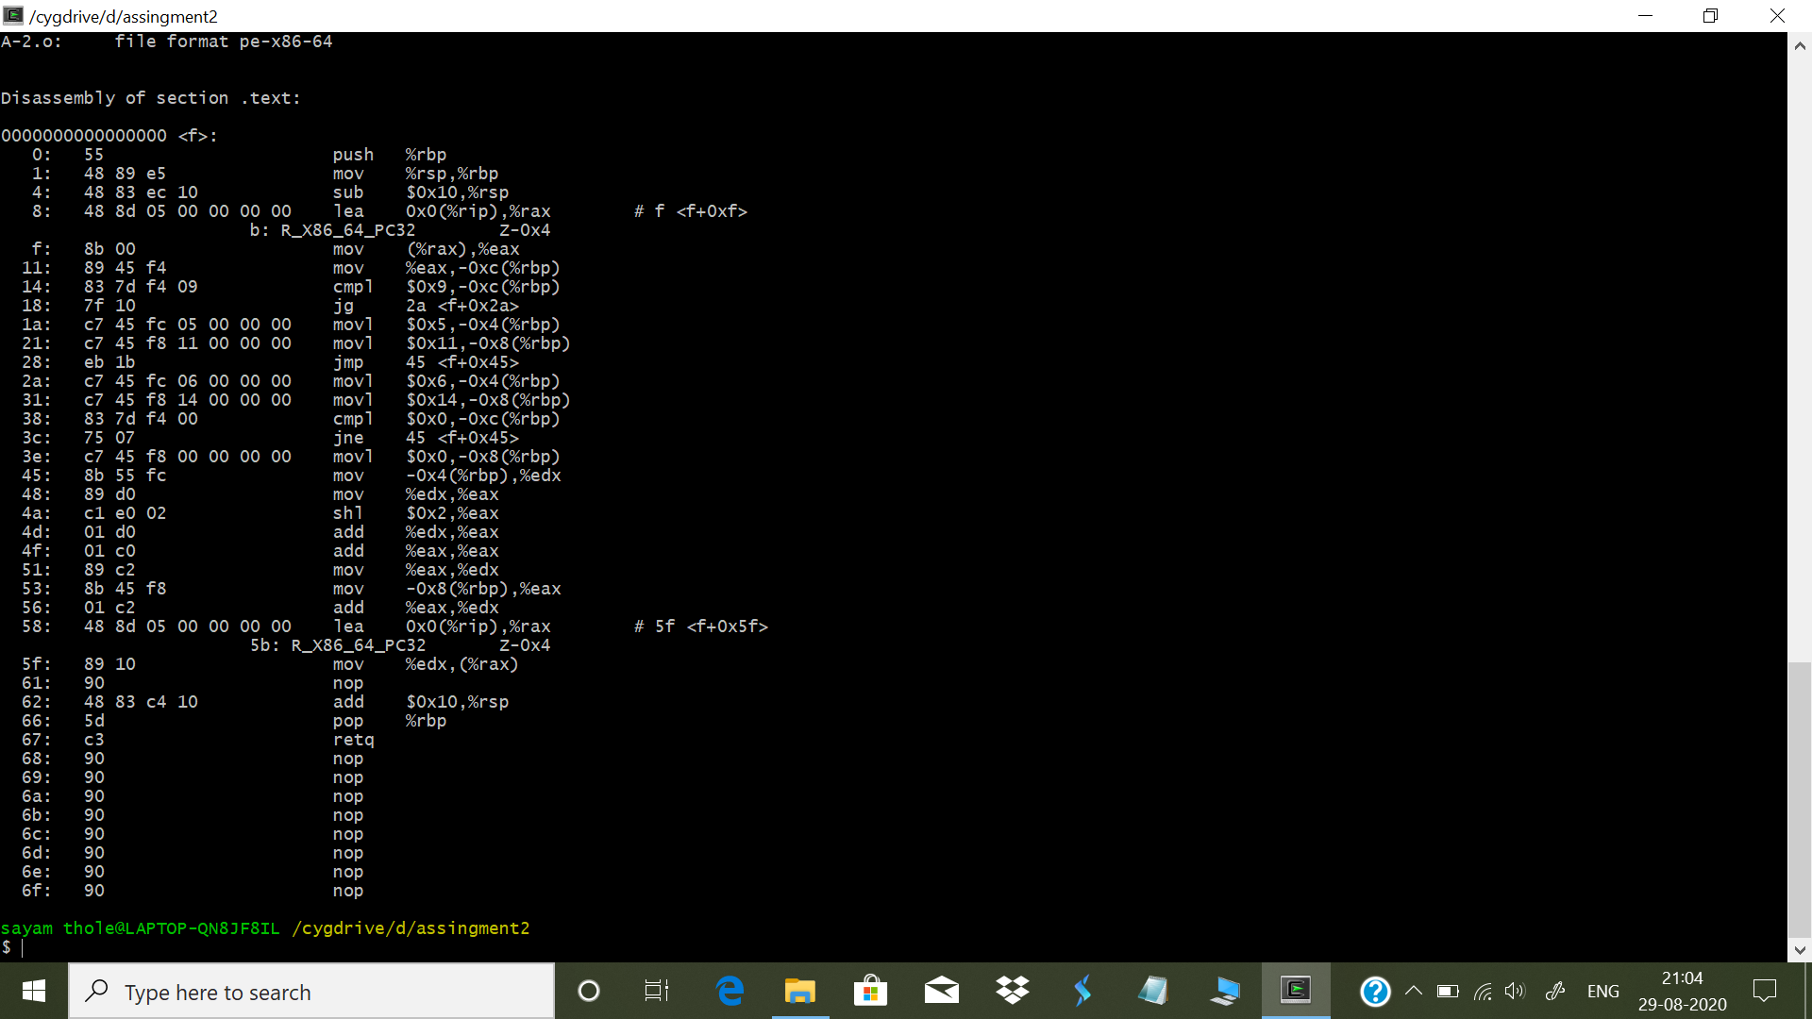

**A-3)**

int main()

{

int sum = 0;

int i, j;

while(sum < 100) {

sum = sum * 2;

}

for(i=0; i<25; i++) {

for(j=0; j<50; j++) {

sum = sum + i*j;

}

}

}

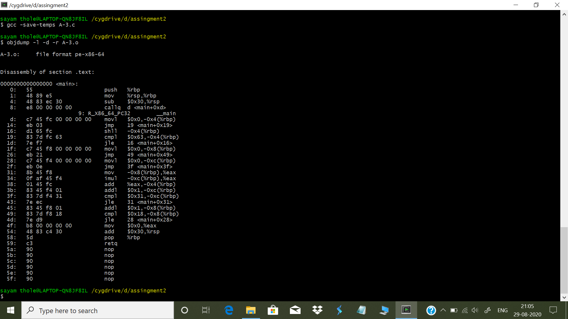

**A-4)**

int main()

{

int a[3];

int b[] = {1, 2, 3};

int i, *p;

for (i=0; i<3; i++) {

a[i] = b[i];

}

p = a;

*(p + 2) = 5;

}

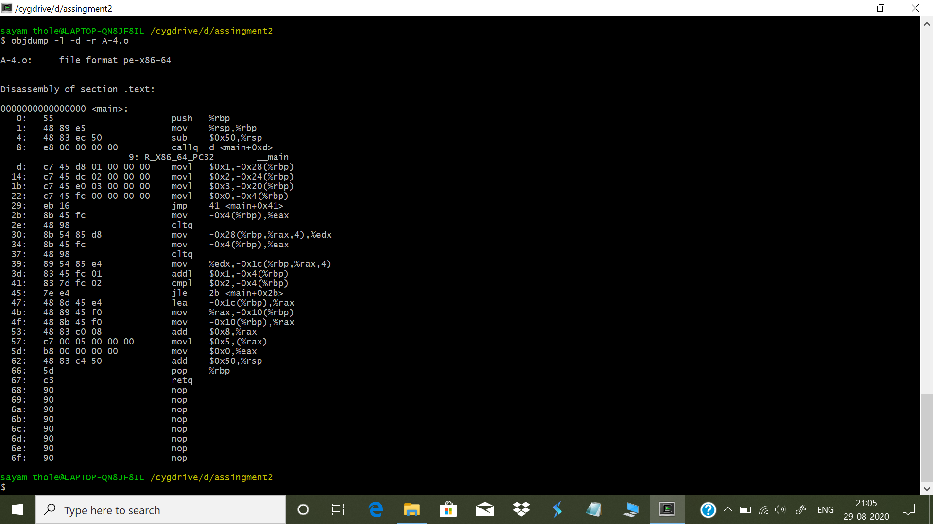

**A-5)**

int main()

{

int a, b, c, d;

d = 10;

if (c > d) {

a = 3;

b = 2;

} else {

a = 2;

b = 3;

}

c = a + b;

}

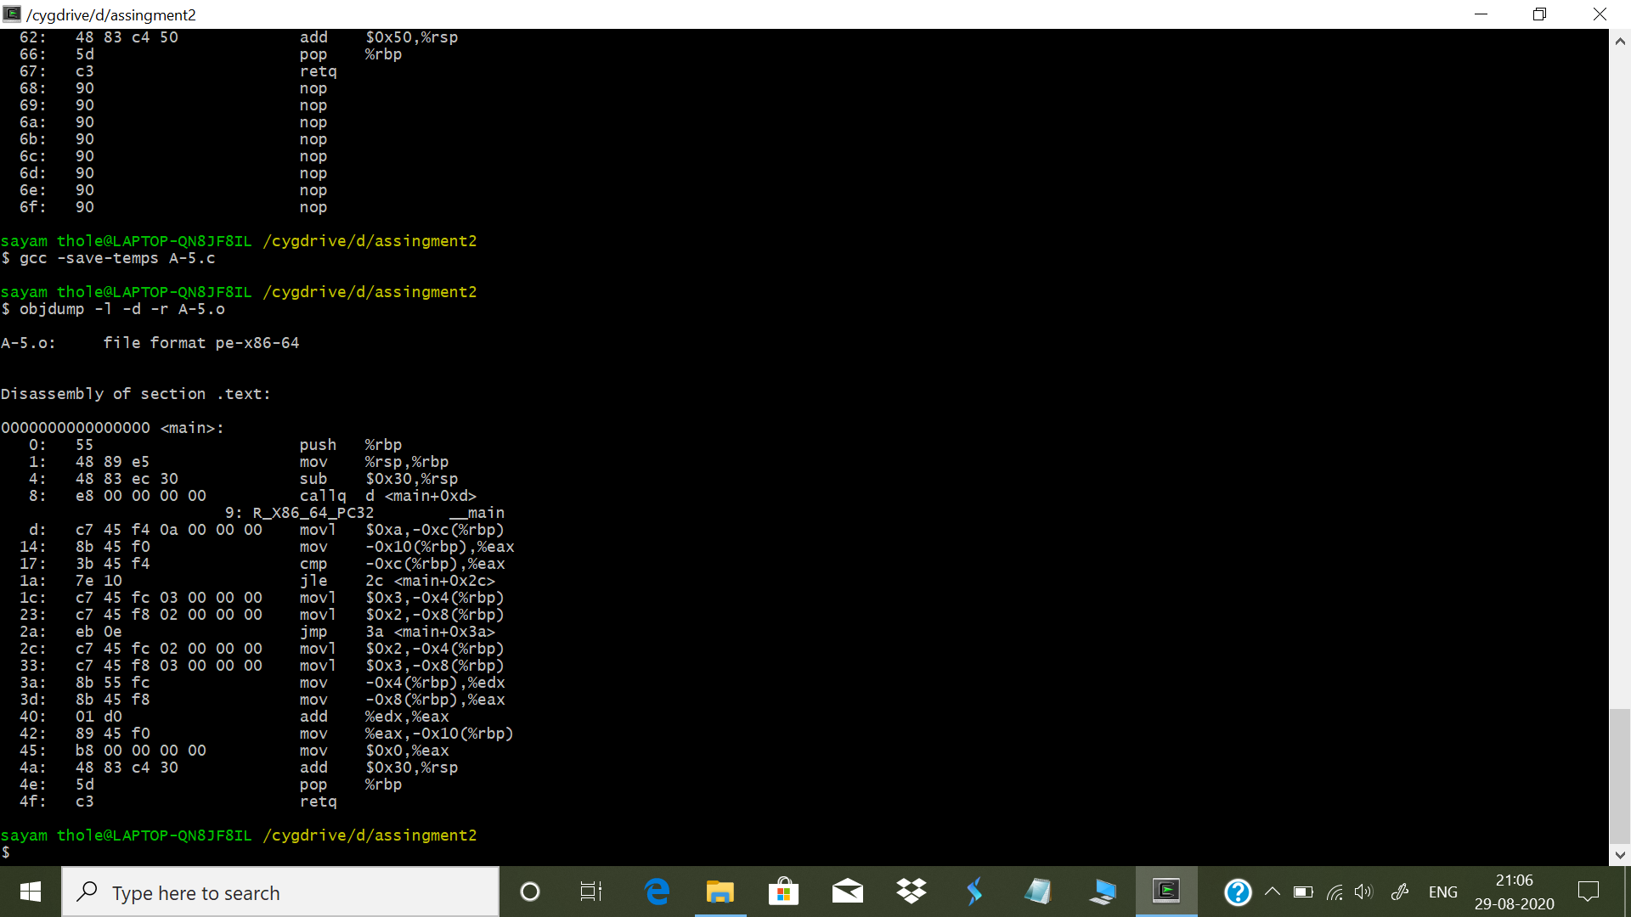

**B-1)**

int AddTwo(int a)

{

a = a + 2;

return a;

}

int main()

{

int x = 3;

x = AddTwo(x);

return x;

}

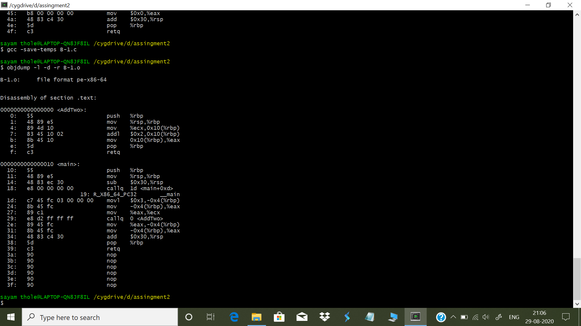

**B-2)**

int N;

int main()

{

int i, a = 10;

for(i= 0; i < 4; i++)

{

a = a + N;

};

return a;

}

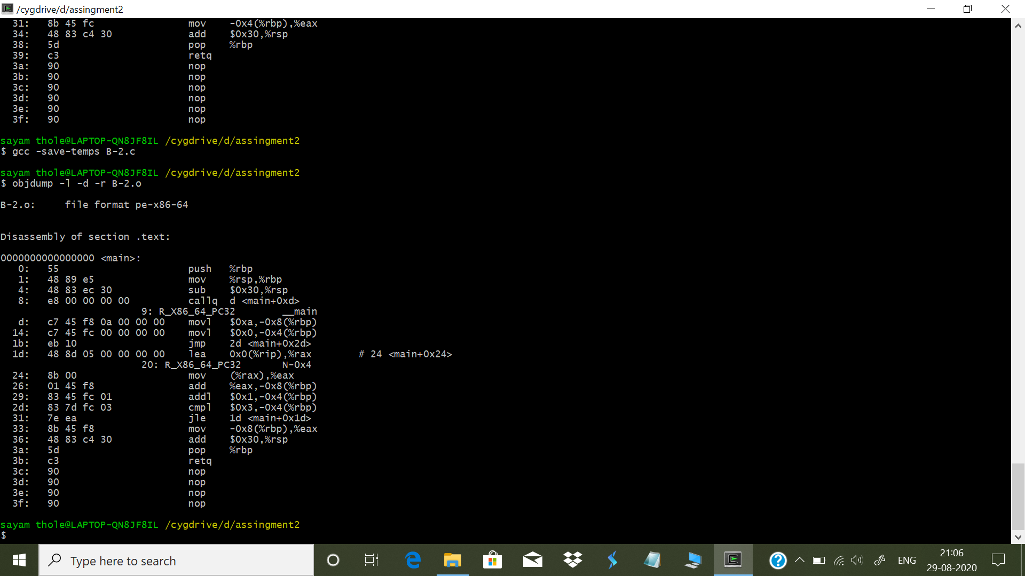

**B-3)**

#include <stdio.h>

int main ()

{

int a, b;

for (a=4 ; a<100; a++) {

if (a < 4)

b = b + 2;

else

b = b * 2;

}

printf ("%d%d", a, b);

}

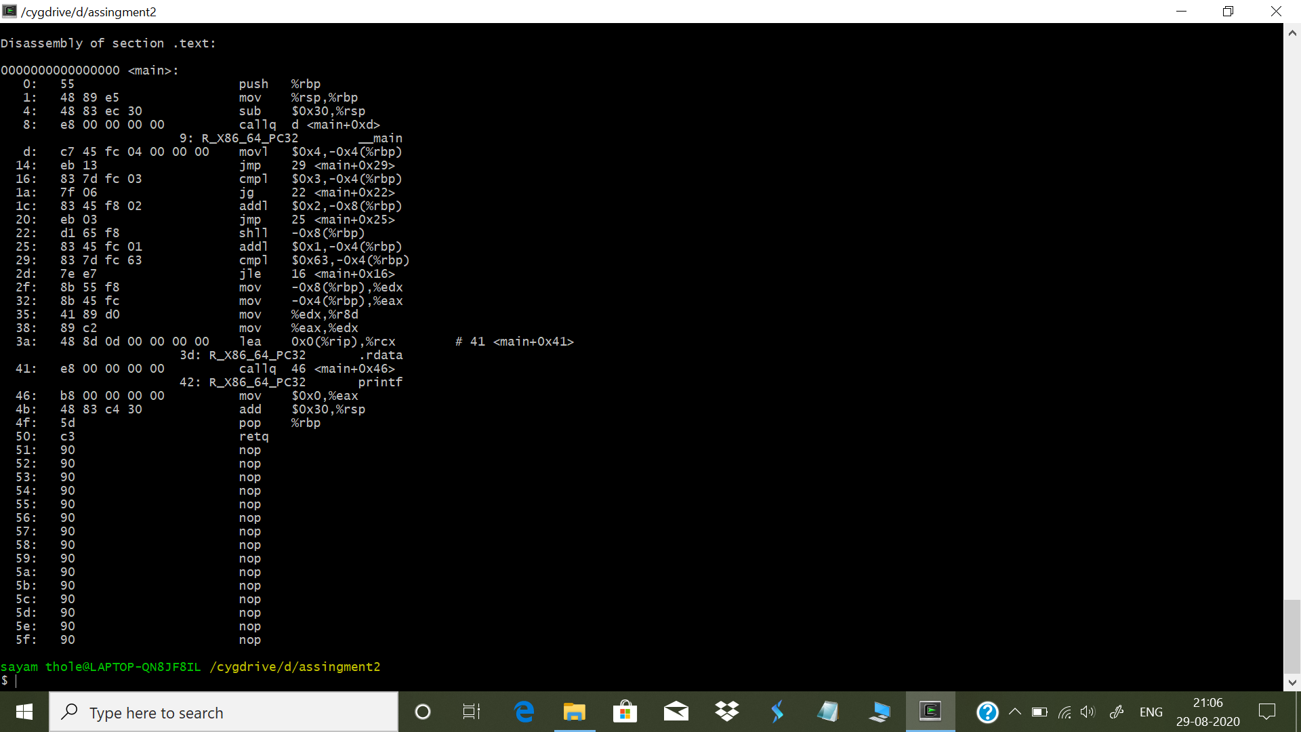

**B-4)**

int main()

{

int a, b, c;

b = (a + c + b) * (c + a);

return b;

}

